
Rocket curser
Placement of Logo under border
Text to adjusted to – Justify – complete Website

About Us and all topics
Font to be adjusted
All text to be justify
Our Mission – Highlight
Spellings – Anuppriya Sharmaa – Add write up
Part Numerologist and full-time professional "vibe" checker she just doesn’t just fill roles; she finds the missing piece of the creative puzzle.

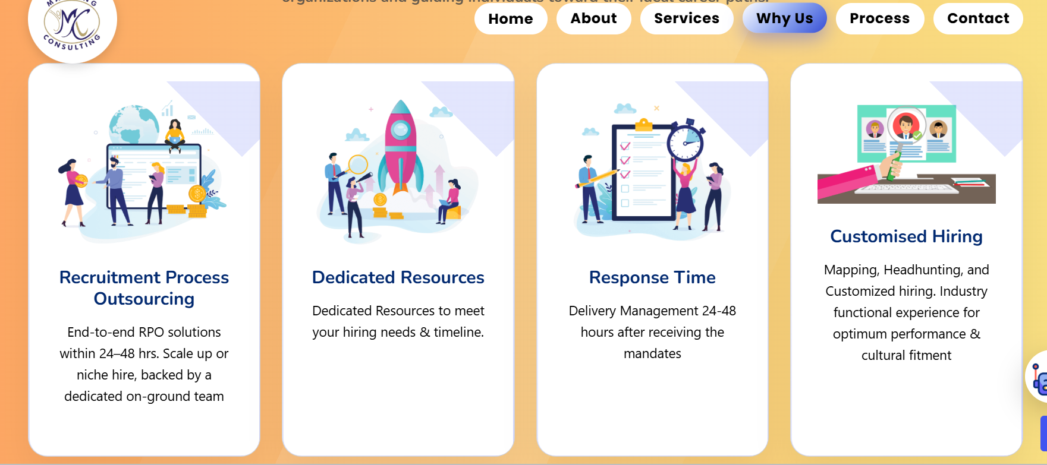

Symmetry?
Rocket effect?
Highlight banner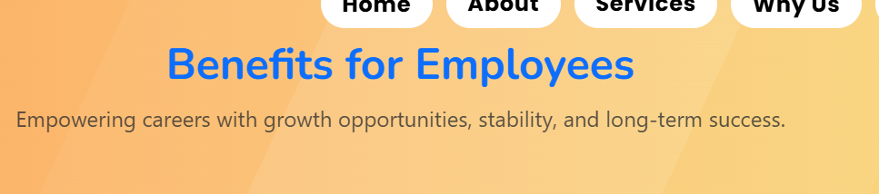


Highlight

Didn’t like Awards and recognition. Feels Left out
Client banner not good



Red is not looking good

